6/29/2019

Kyer Potts

30003389

Database Programming AT1.1

Research Report

Table of Contents

Information Gathering Methods 1

Questionnaires and Surveys 1

Focus Groups 1

Interviews 1

Data Analysis Techniques 2

Quantitative Data Analysis 2

Qualitative Data Analysis 2

Data Mining 3

Data Source Characteristics 4

Accuracy 4

Validity 4

Consistency 4

Timeliness 4

Completeness 4

Uniqueness 4

Information System Features 5

Data 5

People 5

Hardware 5

Software 5

Telecommunications 5

Database Systems and Procedures 6

Software 6

Data Storage 6

Reporting 6

Data Security 6

Data Sharing 6

Data Management 6

References 7

# Information Gathering Methods

## Questionnaires and Surveys

Questionnaires and Surveys are series of questions designed to collect responses in regard to subject matter. Their ease of use and scalable complexity, ranging from simple yes no answers to sliding scales and even matrixes make them versatile tools for data collection. One defining advantage the practically limitless reach a questionnaire or survey can have with the implementation global communication. This allows a broad range of data to be collected from every demographic imaginable if the questionnaire is tailored correctly. The responses can also be designed to allow quantitative analysing techniques by assigning values to varying response options. The major drawback being that responses are typically shallow, and do not capture the intricacy or weight that other methods of data gathering are able to collect.

## Focus Groups

Focus groups generally consist of a small to medium group of people engaging in a carefully moderated discussion on the subject of the survey. These groups can be invaluable to researchers, as it allows for methods or thought patterns that the researchers would not normally have available to them with traditional means. These open conversational methods can lead to abstract reasoning, which can be especially helpful when attempting to quantify data regarding abstract subjects such as emotions or social values. Focus groups also help the researchers to corroborate information very quickly, as any false data will usually be disproven or countered by other participants in the focus group. As a data gathering method, focus groups can be rather inefficient, and require a proportionately large amount of time for subject matter.

## Interviews

Interviewing subjects is one of the oldest and most robust forms of data collection. They are most useful when attempting to collect information on abstract or complex topics or issues, as they allow direct one to one communication between subject and data gathering parties. This bridging between parties allows nuance and depth to be discussed and drawn upon. Data quality is a major concern when utilising interview techniques, and a skilled trained interviewer is often essential to properly direct the flow of the interview and maintain data quality and integrity. Data provided by interviews is often qualitative in nature, and is usually unsuitable for data processing systems when provided in a raw format.

# Data Analysis Techniques

## Quantitative Data Analysis

Due to the mathematical and procedural nature of quantitative data, analysis requires a considered approach. This approach will first prepare the data to ensure that all data submitted for analysis has been validated and is free from fraudulent, incorrect, false or incomplete information. Once these verification checks on the data have been completed, the data is then edited to ensure that the data provided is uniform and can be managed into a calculable state. The data is then coded to assign weighted values to responses. At this stage the data can be divided into different types of statistical groupings for analysis. These are descriptive analysis for descriptive statistics and inferential analysis for inferential statistics. These subgroupings of statistics require different analysis methods for their respective datasets. Descriptive analysis usually results in a numerical outcome, whereas inferential analysis will provide insight regarding the relational outcome between different sets of data. (Bhatia, 2018)

## Qualitative Data Analysis

Qualitative or categorical data analysis also begins with data preparation; however, it differs from quantitative analysis in the methods and outcomes achieved in the preparation of data. Qualitative data generally will not need to be edited or verified for false or incorrect information, however fraud checks should always be implemented to ensure the integrity of data collected. Reading through and gaining familiarity with the data is perhaps the most important step in this process, as it will allow the analyst to begin to identify patterns and correlations between sets of data and outcomes. The analyst must then revisit their research objectives and develop a framework to categorise and identify the abstractions and concepts of the data. Once the framework has been completed the analyst can begin to identify patterns and correlational relationships between datasets.

# Data Mining

Data Mining is the process of finding practical information within largescale data groups to predict future outcomes. Depending on the data and the information that it is being mined for, a broad range of analysis can be achieved based upon historical data to observe trends, reduce risk, maintain and improve relationships, study broad cultural shifts or improve financial position.

# Data Source Characteristics

## Accuracy

Accuracy refers to the precision of the data kept within records. The information must be free of any characterisation errors and must be recorded cleanly and without fault. The importance of accuracy within database elevates relationally to the level of severity of fault that inaccurate data can cause.

## Validity

Most forms of quantitative data require validation reasoning to ensure that datasets are kept uniform and usable with minimal editing or parsing. Validation is generally not a concern outside of quantitative data sources.

## Consistency

Consistency ensures that the data collected is not contradictory or unreliable regarding other data sources. Data sources will usually require a mechanism to inhibit contradictory data or data with unwarranted variances.

## Timeliness

Data needs to be collected at the correct point in time to ensure that all data collected is relevant and represented correctly.

## Completeness

Data collection needs to be comprehensive to ensure that it represents the situations or subject matter appropriately. If the data collected is not complete, predictions or data driven decisions will not have a complete picture to make properly informed choices.

## Uniqueness

The granularity of the data must be maintained to ensure that decisions remain accurate and relevant. Data detail must be managed within their respective levels in order to represent their correct meanings.

# Information System Features

## Data

Data is the most integral component to an information system, as there is no use for an information system if there is no information for it to manage. Prior to entry into an information management system, data should be validated to ensure the data is free from errors or inconsistencies.

## People

People are required to create the information that the system will manage, they are also required to analyse any findings that the information system computes or correlates.

## Hardware

Information and data will need to have relevant hardware to be stored on and retrieved from. Quality of hardware is integral to the database, as unreliable hardware can corrupt, or even lost data, especially if not properly maintained and cared for.

## Software

Software with the necessary features and functionality is also necessary for the information system to allow users to access information. More advanced software might have additional features that will allow the user to automatically interpret information at higher levels.

## Telecommunications

Information will need to be distributed through various persons and levels of the organisation. To do this, a form of telecommunication is required (intranet, internet or voice network). Without it, all persons that require access to the data will need to maintain a direct connection to hardware servers.

# Database Systems and Procedures

## Software

Software is necessary to facilitate the access and distribution of data and information from data storage devices to users and third-party applications. The software in question may be as simple as a data entry interface, to a complex analytical virtual machine that can independently interpret and draw conclusions from data.

## Data Storage

Database management systems all require some form of data storage. Without it, the data will be lost instantly and cannot be stored or retrieved for later user.

## Reporting

Data reporting is necessary to manage the integrity of the data kept by database management systems. Without reporting functionality, upkeep of storage facilitates, and prevention of database or data corruption becomes extremely tedious to impossible depending on the scale and size of the database.

## Data Security

All databases must implement some level of security to ensure that any data collected and stored is not mismanaged, edited or maliciously interfered with. Higher sensitivity data will require more robust forms of data security.

## Data Sharing

Most database management systems for organisations will require some form of data distribution system to allow users to access information and data independently of a device with a direct connection to the data storage facility. Usually this will be in the form of a telecommunications feature.

## Data Management

Data management procedures are necessary to ensure that all data kept within the system adheres to the correct characteristics required within data groupings. These procedures are also necessary to ensure that any data changes or manipulations are verified before taking place. Without these procedures, data integrity is difficult to guarantee.

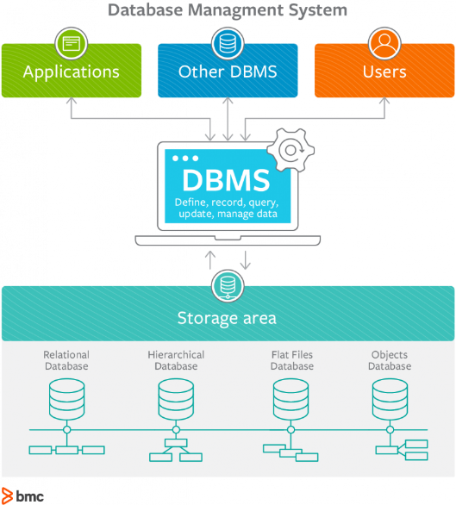

# References

Bhatia, M. (2018, 09 05). *Your Guide to Qualitative and Quantitative Data Analysis Methods*. Retrieved from socialcops: https://blog.socialcops.com/academy/resources/qualitative-quantitative-data-analysis-methods/

Jha, G. (2017, August 16). *4 Data Collection Techniques: Which One's Right for You*. Retrieved from socialcops: https://blog.socialcops.com/academy/resources/4-data-collection-techniques-ones-right/

Ortega, D. (2017, 01 26). *BLAZENT*. Retrieved from Seven Characteristics that Define Quality Data: https://www.blazent.com/seven-characteristics-define-quality-data/

Raza, M. (2018, 08 29). *bmcblogs*. Retrieved from Introduction to Database Management Systems (DBMS): https://www.bmc.com/blogs/dbms-database-management-systems/

SAS. (2019). *SAS The Power to Know*. Retrieved from Data Mining What it is and Why it Matters: https://www.sas.com/en_au/insights/analytics/data-mining.html

Sean. (2015, 09 23). *AnswerKid*. Retrieved from Features and Functions of Information Systems: http://www.answerkid.co.uk/features-and-functions-of-information-systems/

University of Minnesota. (2019). *Data Collection Techniques*. Retrieved from CYFAR: https://cyfar.org/data-collection-techniques